The z/OS Connect EE Perspective

# Section 1: Opening the Perspective

**Option 1)**

Click the “orange ball” icon near the top left of the main screen.

*Hint: If you hover over the icon, the words “z/OS Connect Enterprise Edition” will appear*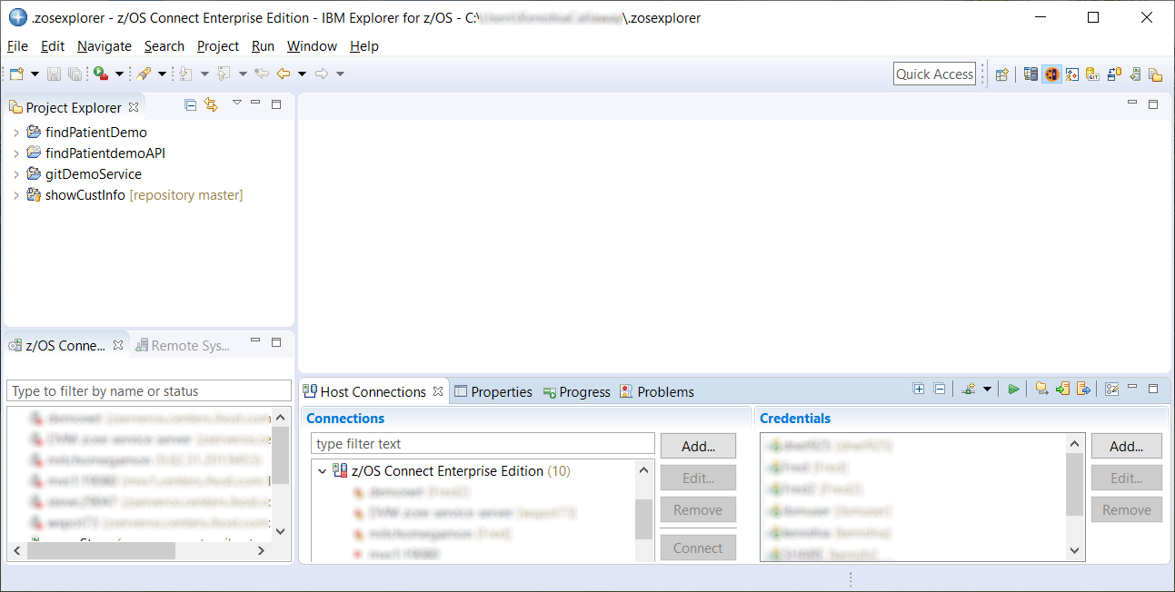dow.

**Option 2)**

If you do not see the orange ball, click **Window** -> **Perspective** ->**Other**

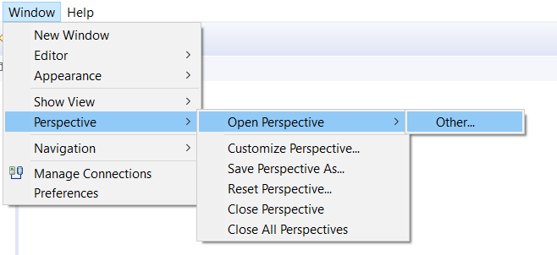

In the popup window, scroll to **z/OS Connect Enterprise Edition**, click to select it and then click **OK**

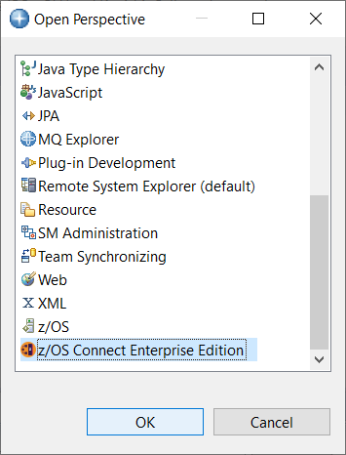

# Section 2: The Default Perspective Appearance

Below is a picture of the default view of the z/OS Connect EE Perspective



**3**

**2**

**1**

**7**

**4**

**6**

**5**

Project Explorer

1. **Shortcuts**
   1. This is a pictoral menu of perspectives. It does not show all perspectives that are available.
   2. To open a perspective that is not appearing as a shortcut, click the  icon and a pop-up menu will appear.
2. **Toolbar**
   1. Quick way to launch some menu options
   2. The left most icon  opens the pop-up menu to create a new project.
3. **Project Explorer**
   1. This is a list of Service and API Projects that have either been created or imported into the toolkit.
   2. When a project is created, it will appear in this section.
   3. Projects are organized as folders with subfolders for some elements

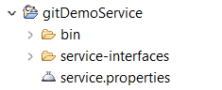

* 1. To open a Service for editing, double-click on the service.properties file inside the project folder.
  2. To open an API for editing, double-click on the package.xml file inside the project folder.
  3. To **deploy** a Service or API, right click on the project folder and choose z/OS Connect EE -> Deploy

1. **Service/API Editor View**
   1. When a Service or API configuration file is opened, the contents appear in this section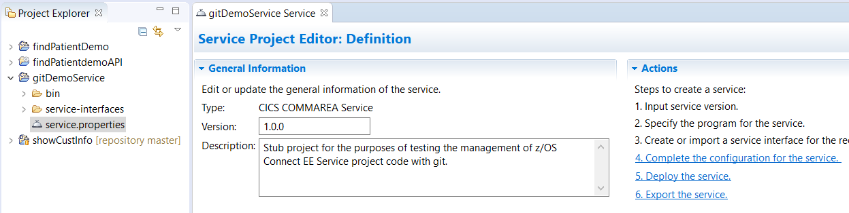
   2. If any changes have been made, an asterisk (*) will appear in the tab, indicating that the project needs to be saved.
2. z/OS Connect EE Servers
   1. If you have configured access to a z/OS Connect EE server, then the server will appear in this section.
   2. This view allows connected users to view Services and APIs that have been deployed on the server
   3. Those with proper access rights (maintained by the z/OS Connect EE Administrator) will be able to start, stop, remove Services and APIs in this view.
   4. This view also provides access to the SwaggerUI testing tool

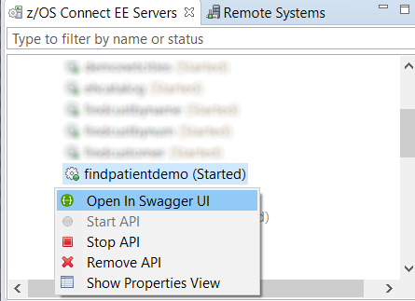

1. Host Connections, etc
   1. Host Connections – list of all the server connections available through the tool
      1. Connections are categorized by system/subsystem (ex: z/OS Connect Enterprise Edition)
      2. A host connection must be made to a server before it will appear in the z/OS Connect Servers view
   2. Properties – more information about a selected element
      1. Properties data is available for Projects, Services and APIs
      2. Data for Services and APIs includes the urls for invoking them
   3. Progress – displays operations data
   4. Problems – displays problem/error messages and details
      1. Good source of information if a project fails to save or deploy
2. Credentials
   1. Holds credentials used to access the resources listed in Host Connections (such as userid and optionally password)